- Hemophilia (A)
- A. Mother XhXH father XhXh
B. 25%
C.
. 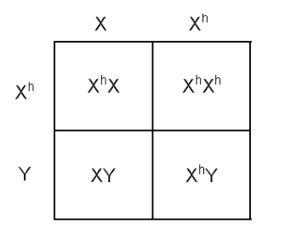
Genotypic ratio: 1;1;1;1
Female carrier is 25%
Female hemophilia is 25%
Male normal is 25%
Male Hemophilia is 25%

- A. Mother BO father AB
B.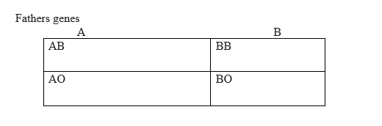

4.Deletion(B)
5. both their daughters and sons; only their daughters (D)
6. 2 daughters and 1 son(B)
7. Environmental effects have introduced nongenetic variation during growth.(A)
8. True.
9. B
10. Type B

O

BO | OO
BO | OO

O.

11. two-thirds(B)
12. True
13. A. AA
B. OO
C. AO
 | A | A
O | AO | AO
O | AO | AO

14. fruit flies (B)
15. all of these are possible(A)
16. None since he will also be just a carrier(E)
17. False
18. polygenic(A)
19. environmental factors on the ability of genes to express themselves. (B)
20. True
21. b. c
22. all of the choices are correct(C)
23. c. a
24. Translocation (E)
25. A. BO
B. BO, AB

ASSIGNMENT 9.
- True
- True
- Hydrogen bonding.
the fact that complementary bases fit together physically

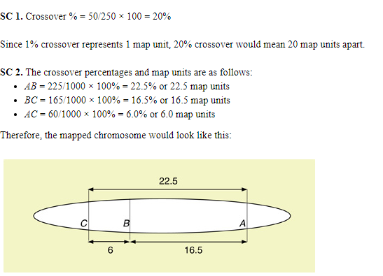

- Exons(A)
- Injected heat-killed S-form bacteria together with live R-form bacteria killed mice(D)
- is only semi-conservative in eukaryotes, not prokaryotes(B)
- Too little information provided(B)
- The genetic code is redundant. (C)
- True
- True
- A hydroxyl group on the 3' carbon of a deoxyribose sugar. (A)
- RNA polymerase(C)
- True
- False
- adenine, thymine, cytosine and guanine(B)
- amino acids(A)
- True
- True
- True
- 1% crossing over between two sites on a chromosome. (A)
- True
- True
- the amplification of a specific region of the DNA for further study(C)
- Somatic- this refers to the copying of a portion of DNA to any body cell that is not responsible for producing eggs or sperm.
Germline- this refers to the copying of a portion of DNA that produces eggs or sperm.
- GGG(C)
- True
- Tryptophan, phenylalanine, Alanine., Isoleucine, proline, Serine, Glycine, Tryptophan, Isoleucine
- True
- True
- . single-stranded DNA(B)

ASSIGNMENT 10

- 16%(B)
- The values of allele frequencies are always between 0 and 1. (A)
- True
- There was enough heritable variation in the wild canine species to create a variety of features(A)
- True
- Inherited genetic differences(D)
- Point mutation.
Frameshift mutations.
- Mutation leads to immediate change in adaptation while natural selection is where change in adaptation takes place over a number of generations.
- heterozygote advantage involves a situation where a heterozygote individual has benefits over a homozygote individual. Example when an allele that causes infection becomes good for the immune of a single person.
- Natural selection leads to an increased variation in gene and allele adaptation. Speciation occurs when beings that survive natural selection can survive and reproduce.
- True
- With natural selection "picking" is due to the fit of an organism with its environment; whereas in artificial selection, the breeder "picks" which organisms will breed. (D)
- None of the options. (A)
- Individuals better adapted to the environment tend to leave more offspring. (B)
- It should increase in frequency(A)
- from mutations producing novel alleles and from recombination producing new combinations of traits(E)
- the gene pool must have balanced polymorphism(D)

18.M- 0.6
N- 0.4
MN- 1
MM- 0.36
NN- 0.16
B. .M- 0.52
N- 0.48
MN- 1
MM- 0.2704
NN- 0.2304
C. the population of question 1 consists of one species that is dominant over the other while the second population consists of species with equal dominance.
19.A. Hypothesis: Geographical isolation can lead difference in mutations into different species.
The presence of geographical barriers can lead to interbreeding problems making one species really fertile while other remains infertile.
B. Reproductive isolation can still be affected due to adaptively splitting into two different species hence can no longer interbreeds.
20. Marge dies her hair
21. blue. (C)
22. mutation(B)
23. birds that eat moths(C)
24. Sexual selection is a type of natural selection. (C)
25. True
26.
Generation n | Number of AA | Number of Aa | Number of aa | p | q
F1 | 40 | 45 | 15 | 0.4 | 0.6
F2 | 38 | 49 | 13 | 0.38 | 0.62
F3 | 45 | 40 | 15 | 0.45 | 0.55
F4 | 46 | 48 | 6 | 0.46 | 0.54
F5 | 44 | 40 | 16 | 0.44 | 0.56

ASSIGNMENT 11
- multiregional hypothesis(A)
- Genetic variation in a gene pool can be increased by increasing the frequency of recombination.
- Macroevolution(A)
- a bottleneck (D)
- Speciation by Polyploidy is the mutation that is abnormal during metaphase or mitosis.
- False.
- Animals rarely self-fertilize, so diploid gametes are much less likely to fuse. (D)
- allelic change(D)
- True
- genetic set that identifies a species (A)
- Diversity is important in long term survival because the level of their adaptivity to new environments and drifting circumstances and distractions rest on diversity.
- spontaneous mutation(A)
- Punctuated equilibrium happens when there are sessions of stasis that are interrupted by sudden change while gradualism happens slowly over a very long period of time.
- False
- reproductive isolation and genetic divergence(C)
- gene flow (A)
- Geographic Speciation Model- Creates geographical boundaries.
Gradual Speciation by Habitat Splitting- creates separation in their natural habitat.
Speciation Without Physical Isolation- separation without the geographical isolation.
Gradual Speciation on Islands- creates a system for either survival or extinction.

ASSIGNMENT 12.
1.a. it states that two organisms that are constantly competing for resources cannot coexist stably.
b. it provides competition between individuals of the same species and those of different species.

2. aphid and ladybug- mutualism
barnacles and whale- mutualism
flea and dog- parasitism.
bacteria and sewage- mutualism
bird and trees- commensalism
ant and caterpillar- predation
birds and berries- commensalism
coli and large intestine- Detritivory
3.False
4.A new, isolated population of fruit flies is founded by a small group of colonists, which then diverge from the ancestral source population. (C)
5. Population can be distributed by size, density and distribution in space. It can be distributed due to Physical factors or natural selection.
6. . All of the choices(A)
7.A. lag,
exponential (log),
stationary
death
B. when birth and death rate are the same.
8.Fierce rivalry to control resources- this is due to lack of enough resources to be distributed to every individual.
9. True
10. 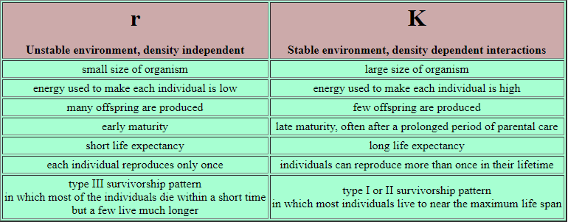
11. true.
12. False.
13. True
14. False
15. False
16. True

